编号：
Number:

绿色再生塑料供应链联合工作组入组申请表
APPLICATION FOR GRPG MEMBERSHIP

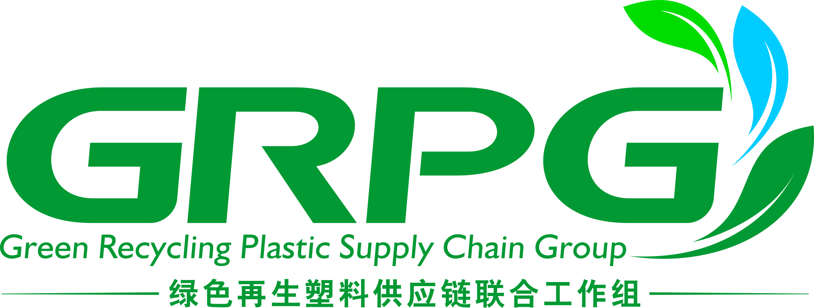

公司名称：
Company Name:

填表日期：
Date:

中国石油与化学工业联合会
China Petroleum and Chemical Industry Federation
北京朝阳区亚运村安慧里四区16号楼中国化工大厦
No. 16 Bldg, anhuili siqu, chaoyang district, Beijing
电话 01084885114
传真 01084885096

中国物资再生协会再生塑料分会
China Plastics Recycling Association of CRRA
北京市通州区绿地中央广场二期写字楼1612
1612, Building 1, Greenland Central Square, Xinhua North Road, Tongzhou District, Beijing, 101100, China
电话Tel: 0086-10-57721789
传真Fax:0086-10-56865400
邮箱Email: crra@chinacrra.org

绿色再生塑料供应链联合工作组加入指南
Guide for Membership Application of GRPG

- 申请加入本工作组的成员，应具备的条件和履行的义务如下：
Article 1 The members who apply to join GRPG shall meet the following conditions and obligations:
- 认同工作组的理念，承认并遵守工作规程，执行工作组通过的各项决议和规定；
Agree to the concept of GRPG, recognize and abide by the working rules, carry out resolutions and regulations adopted by GRPG.
- 按规定缴纳费用；
Remit membership dues as required.
- 热心支持、积极参与工作组的工作和各项活动；
Support and actively participate the works and activities of GRPG
- 维护本工作组的合法权益和声誉；
Maintain legal rights and reputation of GRPG
- 遵守中华人民共和国的法律、法规和政策，并具有良好的商业信誉。Abide by the laws, regulations and policies of PR China, and have a good business reputaion.
- 加入本工作组的程序是：
Article 2 Procedure to join in GRPG
1、企业提交入组申请表及相关资料；
Submit application form and relating documents;
2、由提名委员会初审，符合加入条件；
Preliminary review by nomination committee on conditions of joining;
3、所有成员单位投票，支持票数超过2/3即可加入；
More than 2/3 ayes in the vote;
4、正式确认成员
Membership confirmed officially.
- 成员享有下列权利：
Article 3 Members enjoy the following rights:
- 本工作组的选举权、被选举权和表决权;
The right to vote, to be elected,and voting power in GRPG
- 参加本工作组组织的有关活动;
Participation in relative activities organized by GRPG
- 享受本工作组提供的各项服务；
Services provided by GRPG
- 要求本工作组为维护成员的合法权益给予帮助；
Request GRPG to help protect the legitimate rights and interests of members;
- 对本工作组的工作进行监督，提出意见和建议；
Supervision of GRPG’s work and putting forward opinions and suggestions.
- 推荐新成员
Recommendation of new members.
- 退出本工作组的自由
Freedom to quit GRPG
- 成员退出需要书面通知本工作组。成员有下列情况之一者，本工作组可终止其成员资格，并在工作组通讯上公布。
Article 4 Members must notify GRPG in writting for quitting GRPG. If member has one of the following circumstances, GRPG can terminate the membership and announce it in the GRPG’s communication.
- 1年不缴纳费用者；
Those who do not remit dues for 1 year;
- 1年不参与本工作活动者；
Those who do not participate activities organized by GRPG for 1 year;
- 成员如有严重违反本工作条例的行为，经领导小组通过，予以除名。
Article 5 Any member who seriously violates these work regulations shall be removed from GRPG after being approved by the leading group.

绿色再生塑料供应链联合工作组愿景和实现途径
GRPG’s vision and way-to-realize

愿景What we do
我们希望通过使用更多的再生塑料，减少产业环境影响足迹，更好地保护我们的地球。这将意味着整个价值链——全球的品牌、零售商、材料供应商、行业协会和其他和我们拥有相同愿景组织的通力合作，携手打造一个全新的协同模式。
We want to protect the planet by using more recycled plastics which will reduce the industry's environmental footprint. That means working closely with the entire value chain. We collaborate with global brands, retailers, material suppliers, industrial associations and other organizations that share our vision. Together we create a new way forward.

途径——合作推进废塑料循环利用How-Moving forward together to recycle plastics
我们相信所有废塑料都可以通过回收方式实现合理的再利用，从而清除塑料废弃物的污染。我们通过价值链合作和模式创新，优化塑料回收利用途径，推动产品生态设计，为实现一个没有“塑料废弃物”的地球而努力。
We believe in a world where plastics won’t pollute the planet and all the plastics can be recycled for a proper second life. Our goal is to make that happen. We connect and innovate to rebuild the way of plastics recycling and change how products are designed. Together we can have a place without “plastics waste”.

我们的使命和愿景建立在更广泛的利益相关方积极参与基础之上，只有这样，才能使得不同来源的废塑料得到安全高效回收，不同种类的再生塑料得到无害化、资源化和高值化的科学合理应用。我们通过更透明的流程来打破行业合作之间的“壁垒”，通过可溯源的体系来为消费者提供更安全和安心的产品。
We are building mission and vision with wider engagement to make the best use of different types of recycled plastics via various resources. To close the gap of the industry, we will be able to have a more transparency process as well as a safer product for the consumers.

—成员资格申请表—
— Membership Application FORM—

单位名称  Company Name | 中文：
 | English：
标准单位简称  Abbreviated Name | 中文：
 | English：
联系人姓名
Name
职衔
Title
联系人手机
Mobile
联系人邮箱
E-mail

公司地址
Company Address
城市  City |  | 省  Province |  | 邮编  Postal Code
详细地址
Address:
单位电话  Company Phone |  | 单位传真  Company Fax |  | 网址  Website
邮寄地址Mailing Address |  | 地址同上Sameascompanyaddress
城市  City |  | 省  Province |  | 邮编  Postal Code
详细地址
Address

*本表所填写联系人将成为成员单位在工作组的主要联系人，将接收工作组发出的所有邮件和信息
The contact person fulfilled in this blank will be the representative in GRPG, who will receive all emails and informations sent by GRPG

推荐单位（推荐人）Recruit By
推荐单位名称
Company Name
推荐人
Name
推荐人职衔
Title
推荐人手机
Phone
推荐人邮箱
Email
推荐人意见
Opinion of Recommendation

谅解备忘录
Memorandum of Understanding

本谅解备忘录（以下简称“备忘录”）于 2020 年 ___月 ______ 日（以下简称“生效日”）签订：

This Memorandum of Understanding (hereinafter referred to as "MOU") was signed on ________ 2020 (hereinafter referred to as "Effective Date") :

- 目的
I. Purpose

本备忘录的目的是达成多方合作框架，在此框架内成立绿色再生塑料供应链联合工作组（以下简称“工作组”）。
The purpose of this MOU is to reach a multi-party cooperation framework, within which a joint working group on green recycled plastics supply chain (hereinafter referred to as the "GRPG") will be established.

- 工作组的目标
II. GRPG Goals

工作组的成立是为了打破再生塑料产业链各环节在推进塑料循环经济过程中遇到的行业瓶颈，构建上下游皆认可的绿色供应链体系，同时向政府相关部门提供政策咨询及建议。
The GRPG was established to break the industry bottleneck encountered by all stakeholders of the plastics recycling industry chain in promoting the plastic circular economy, build a green supply chain system that is recognized by both upstream and downstream, and provide policy advices and suggestions to relevant government departments.

工作组的主要工作为：贯穿再生塑料全生命周期的标准体系的构建；推动上下游共同采信该标准体系，通过细分应用领域再生塑料的循环利用，逐步实现再生塑料全产业链的循环经济。
The main tasks of the GRPG: construction of a standard system that runs through the entire life cycle of recycled plastics; promoting upstream and downstream joint adoption of the standard system and gradually realize the circular economy of the entire industrial chain of recycled plastics through subdividing application fields of the recycled plastics.

- 工作形式
III. Form of work

工作组由各单位指派1-2名代表参与，定期举行会议及活动，就工作组的工作内容和节奏进行讨论、协商。

1-2 representatives from each party are assigned to work in the GRPG and to participate in regular meetings and activities to discuss and negotiate the working content and progress.

- 费用
IV. Costs

工作组日常经费由各单位各自承担，工作组接受企业资助开展相关活动，各单位各自承担相应的参会费用，如相关活动有额外费用需各方分担，由工作组另行协商决定。。

The daily operation funding of the GRPG is borne by each party. The GRPG accepts corporate funding to conduct related activities. Each party shall afford the corresponding participation costs. If there are additional costs for related activities that need to be shared by all parties, the GRPG will decide through consultation.

- 非排他原则
V. Non-exclusive principles

除非另有约定明确规定，各方在本备忘录项下属于非排他的关系。。
Unless otherwise specified in the agreement, the parties belong to a non-exclusive relationship under this MOU.

- 文本
VI. Copies

本备忘录由各发起单位以确认函的形式签署。
本文件为中英文双语版本。一切内容以中文版本为准，英文翻译仅供参考。
各方授权代表于上述日期同意本备忘录，本备忘录将在该日期开始生效，有效期两年。

This MOU is signed by each party in the form of confirmation letters.
This document is a bilingual version in Chinese and English. All contents are subject to Chinese version and English translation is for reference only.
The authorized representatives of each party agree this MOU on the above date, and this MOU will take effect on this date. The MOU is valid for two years.

关于加入《绿色再生塑料供应链联合工作组》
确认函
Confirmation Letter of Joining the
Green Recycled Plastics Supply Chain Joint Working Group(GRPG)

本公司确认加入“绿色再生塑料供应链联合工作组”，并承诺遵守工作组的相关规定，积极参与工作组的工作，确认可签署谅解备忘录。

We confirm the participation in the Green Recycled Plastics Supply Chain Joint Working Group(hereinafter refer to as GRPG) and promise to abide by the relevant regulations of the GRPG, actively participate in the work of GRPG, and confirm that we can sign the memorandum of understanding(MOU).

单位名称company name：

盖章Signature/seal：

日期Date：

